

*Operating Lease Support System Phase-2 Project*

*for*



***Functional Specification FC.AD.2.5***

***Manage Work Order***

Revision 1.0

**PT. Berlian Sistem Informasi**

KTB Annex Bld. 4th Floor, Jl. Jend. A. Yani. Pulomas,

Tel. +62 21 4786 7575 (Hunting) Fax. +62 21 4714964 www.bsi.co.id

Document Control

|  |  |
| --- | --- |
| **Author** | Dimas Oktarianto |
| **File Name** |  |
| **Path** |  |
| **Number of Pages** |  |

Revision History

|  |  |  |  |
| --- | --- | --- | --- |
| **Date** | **Revision** | **Description** | **Author** |
| 23/12/2015 | 0.0 | Initial Creation | Dimas Oktarianto |
| 04/01/2016 | 0.1 | QCO Review :   * Adding content to work order (Page 24). | Dimas Oktarianto |
| 12/01/2016 | 1.0 | 1st Baseline | Dimas Oktarianto |

Distribution List

|  |  |  |
| --- | --- | --- |
| Name | Organization | Roles |
| Mr. Setsuya Yoshino | Dipo Star Finance, PT | DSF Project Owner |
| Mr. Yutaro Sanada | Dipo Star Finance, PT | DSF Project Director |
| Mr. Shinji Hosokawa | Dipo Star Finance, PT | DSF Project Director |
| Mr. Shinya Tsukamoto | Dipo Star Finance, PT | DSF IT Advisor |
| Mr. Ahmad Fikri | Dipo Star Finance, PT | DSF IT Advisor |
| Mr. Roby Wijaya | Dipo Star Finance, PT | DSF PMO |
| Mr. Abdul Somad | Dipo Star Finance, PT | DSF Biz. Operation Leader |
| Mr. Mukhlis Ibrahim | Dipo Star Finance, PT | DSF IT Operation Leader |
| Mr. Delta Riangga | Dipo Star Finance, PT | DSF Key User |
| Mr. Mochamad Idris | Dipo Star Finance, PT | DSF Key User |
| Mrs. Herni Hembang | Dipo Star Finance, PT | DSF Key User |
| Mr. Junaidi Didy | Dipo Star Finance, PT | DSF Key User |
| Mr. Dedi Supriyadi | Dipo Star Finance, PT | DSF Key User |
| Mrs. Elke Hilviana | Dipo Star Finance, PT | DSF Key User |
| Mr. Daiki Kamada | Berlian Sistem Informasi, PT | BSI Project Director |
| Mr. Yoshinori Kawahara | Berlian Sistem Informasi, PT | BSI IT Advisor |
| Mr. Satoshi Koibuchi | Berlian Sistem Informasi, PT | BSI IT Advisor |
| Mr. Grand Zah Putra | Berlian Sistem Informasi, PT | BSI Project Manager |
| Mr. Raymond | Berlian Sistem Informasi, PT | BSI Technical Leader |
| Mr. Dimas Oktarianto | Berlian Sistem Informasi, PT | BSI Business Analyst |

Document Approval

By signing this document I acknowledge I have read the document and give the Project Management Team approval to proceed.

|  |  |  |  |
| --- | --- | --- | --- |
| Role | Name | Signature | Date |
| DSF Project Director | Mr. Yutaro Sanada |  |  |
| DSF Project Director | Mr. Shinji Hosokawa |  |  |
| DSF IT Advisor | Mr. Shinya Tsukamoto |  |  |
| DSF IT Advisor | Mr. Ahmad Fikri |  |  |
| DSF PMO | Mr. Roby Wijaya |  |  |
| DSF DSF Biz. Operation Leader | Mr. Abdul Somad |  |  |
| DSF IT Operation Leader | Mr. Mukhlis Ibrahim |  |  |
| BSI Project Director | Mr. Daiki Kamada |  |  |
| BSI Project Manager | Mr. Grand Zah Putra |  |  |
| BSI Technical Leader | Mr. Raymond |  |  |
| BSI Business Analyst | Mr. Dimas Oktarianto |  |  |

Table of Contents

Document Control 2

Revision History 2

Distribution List 3

Document Approval 4

1 Introduction 6

1.1 Purpose 6

1.2 Scope 6

1.3 Definitions, Acronyms, and Abbreviations 6

1.4 References 6

2 Configuration 6

3 Process Specification: AD.2.5 Manage Work Order 7

3.1 Purpose 7

3.2 Screen of Configuration Access 7

3.3 Screen Functionality 7

3.4 Operation Flow 7

3.5 Screen Detail 9

3.6 Screen Functionality 12

3.7 Operation Description 14

3.8 Data Structure 22

3.9 Screen Item List 24

3.10 Entity Relationship Diagram 26

1. Introduction
   1. Purpose

Functional Specification is a document to describe the detail of functions system which includes screen design and logic formula. This document will be used for system development.

* 1. Scope

Functional Specification Document contains screen design, screen functionality, process flow, and data structure of AD.2.5 Manage Work Order.

Here are the scope for AD.2.5 Monitor Work Order :

1. **AD.2.5.1 Create Work Order**

To Create Work Order for regular and irregular maintenance.

1. **AD.2.5.2 Submit Work Order**

To Submit and print work order to get approval. Approval by system and DSF Authorize person can Checked, Approve, Reject, Revise.

1. **AD.2.5.4 Edit Work Order**

To Edit Work Order if any mistakes Occur.

1. **AD.2.5.5 Print Work Order**

To Print Work Order.

Output from this function is :

1. PF.AD.2.1. Work Order
   1. Definitions, Acronyms, and Abbreviations

List of definitions that are used in this document :

1. WO = Work Order.
2. MU = Maintenance Unit.
3. OPL = Operating Lease.
4. PO = Purchase Order.
5. BAST = Berita Acara Serah Terima / Handover Report.
   1. References

This functional specification document refers to **“To Be Design” BSI Unit/ Vehicle Maintenance Process**, module:

1. AD.2.5 Manage Work Order.
2. Configuration

Here will be described the format of WO document which will be generated when PIC Maintenance click Save as draft button or Submit button. The format of WO number is:

No. WO : 00242/SPK-DSF/JKC/MONTH/YEAR

Description :

* + The first 4 digits show the sequence number of the WO document. This number will increments whenever new WO document is created.
  + The code ‘SPK-DSF’, is absolute for WO document.
  + The code ‘JKC’ for DSF Branch Office
  + The code ‘MONTH’ will be substituted by 2 digits of month when the WO document is created.
  + The code ‘YEAR’ will be substituted by 4 digits of year when the WO document is created.

1. Process Specification: AD.2.5 Manage Work Order
   1. Purpose

Screen of Manage Work Order will be used by PIC Maintenance to manage work order for maintenance of OPL unit. This Screen Function consist of create work order, submit work order, edit work order, and print work order.

This function covered by **“Manage Work Order”** screen. These screen accessed via the main screen

* 1. Screen of Configuration Access

Here are the access rights for **“Manage Work Order”** screen users:

|  |  |  |  |  |
| --- | --- | --- | --- | --- |
| ***User*** | ***Create*** | ***Read*** | ***Update*** | **Authorization** |
| PIC Maintenance | V | V | V | V |
| HOD | - | V | - | V |
| RM | - | V | - | V |
| Director | - | V | - | V |

Legend : V = Have the access

Note:

1. Create: related to create work order.
2. Read: related to read display list of manage work order.
3. Update: edit work order to revise.
4. Authorization. related to access screen.
   1. Screen Functionality
5. Display Manage Work Order.
6. Submit data work order.
7. Edit data work order.
8. Print work order.
   1. Operation Flow

Below is operation flow for Monitoring and print unit preparation process referring to **To Be Design Document Unit/ Vehicle Maintenance**, AD.2.5. Manage Work Order:

|  |  |
| --- | --- |
| **PIC PC** | **Process** |
|  | Agreement  (OPL Agreement)  Note:  Source  Output & Input    D:\maintenance_agreement\CreateWorkOrder.PNG  Unit Maintenance  (TB\_MTN\_WorkOrder)  Product model  (Product)  Product model  (Product)  Service History  (OPLServiceHistory)  Unit Management  (TB\_MGT)  Monitoring Schedule  (TB\_MTN\_Monschdl) |

Below is operation flow of ‘**Edit Work Order**’ which is used to edit existing PO by PIC OPL HO/Branch:

|  |  |
| --- | --- |
| **PIC PC** | **Process** |
|  | D:\WorkOrder_final\WorkOrder_Edit.PNG  Work Order  (TB\_MTN\_WorkOrder)  Note:  Source  Output & Input |

Below is operation flow of **‘List of Work Order’** which is used to monitor Completion of WO creation and approval from DSF Authorized person:

|  |  |
| --- | --- |
| **PIC PC** | **Process** |
|  | D:\WorkOrder_final\WorkOrder_List.PNG  User  (OPLUser)      Work Order  (TB\_MTN\_WorkOrder)  Monitoring  (TB\_MTN\_Monschdl)  Note:  Source  Output & Input |

Below is operation flow of ‘**View Work Order’** which is used to view created WO, check, revise and approve:

|  |  |
| --- | --- |
| **PIC PC** | **Process** |
|  | D:\WorkOrder_final\WorkOrder_Manage.PNG  Purchase Order  (TB\_PRO\_PO)  Note:  Source  Output & Input |

* 1. Screen Detail
* Screen design of ‘List of Maintenance Agreement’, which will be used as an initial screen for create work order. Work Order create for any condition regular and irregular, PIC Maintenance click button create work order on list of maintenance agreement.

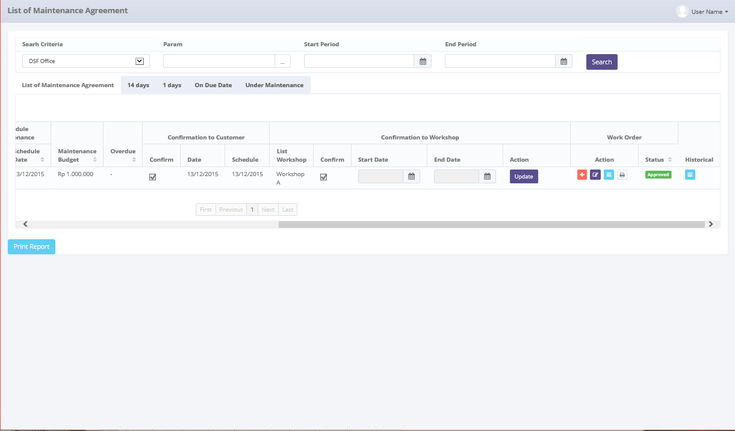

*Screen 1. List of Maintenance Agreement*

* Screen design of “Manage Work Order”, which will be used as second screen for create work order, in this screen PIC Maintenance input price for maintenance cost

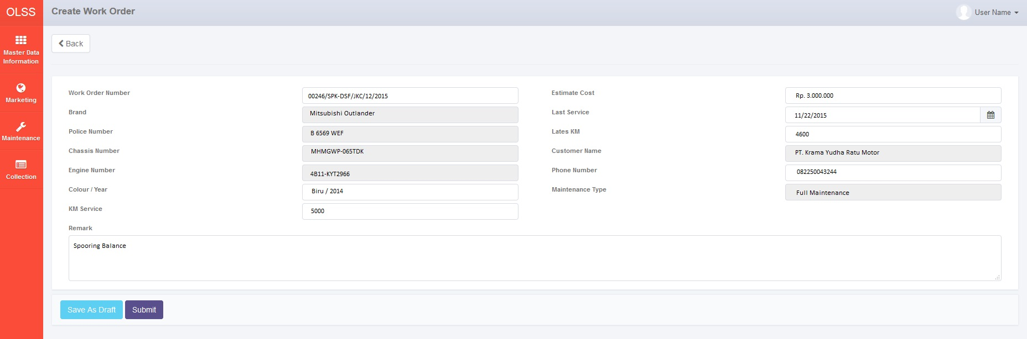

*Screen 2. Create Work Order*

* Screen design of “edit work order”, which will be used as screen for edit work order, in this screen PIC Maintenance update the work order.

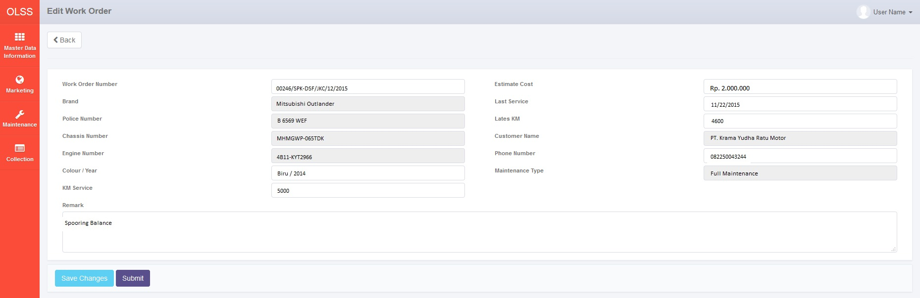

*Screen 3. Edit Work Order*

* Screen “list of WO”, which will be used as screen for approval WO and also list Work Order Maintenance of Unit, in this screen PIC Maintenance update status for WO.

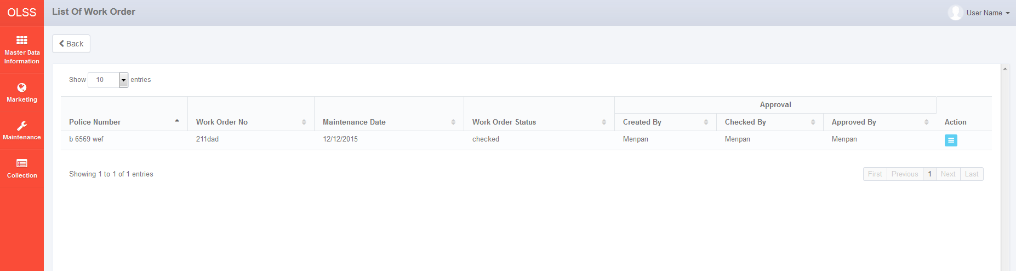

*Screen 4. List of Work Order*

* Screen design of ‘View WorkOrder’, which will display details of the created WO and buttons to revise, check, reject and approve.

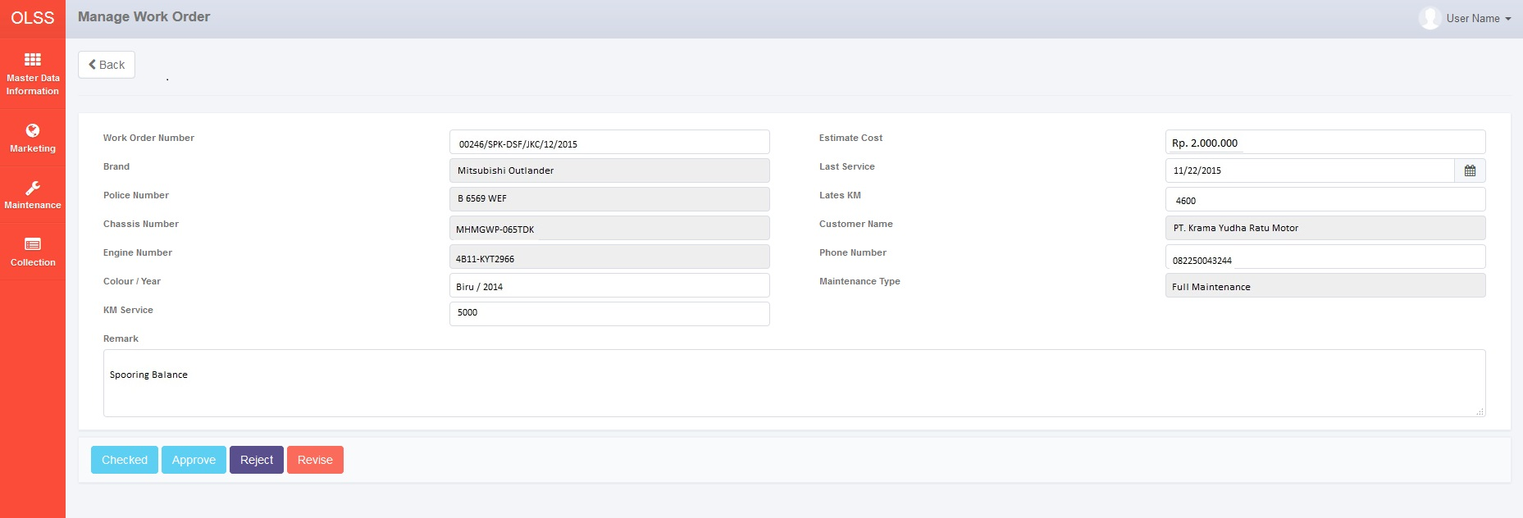

*Screen 5. Manage Work Order*

* *Notification after Revise, Check, Approve and Reject PO*



*Screen 6. Notification After revise, check, approve and reject*

* 1. Screen Functionality

Here are the screen functions from each component in Manage Work Order screen:

|  |  |  |  |
| --- | --- | --- | --- |
| ***No*** | ***Component*** | ***Name*** | ***Function*** |
| **Header** | | | |
| 1. | Label | Work Order | To Display create work order. |
| 2. | Button | Back | To back previous screen. |
| **Create Work Order** | | | |
| 3. | Label | Work Order Number | To display work order number. |
| 4. | Text Field | Work order number | To input work order number. |
| 5. | Label | Brand | To display unit brand. |
| 6. | Text Field | Brand | To display unit brand from database. |
| 7. | Label | Police Number | To display Police Number. |
| 8. | Text Field | Police Number | To display Unit Police Number. |
| 9. | Label | Chasis Number | To display Chasis Number. |
| 10. | Text Field | Chasis Number | To display Unit Chasis Number. |
| 11. | Label | Engine Number | To display Engine Number. |
| 12. | Text Field | Engine Number | To display of Engine Number. |
| 13. | Label | Colour / Year | To display Colour / year. |
| 14. | Field Text | Colour / Year | To display Unit of colour / year. |
| 15. | Label | KM Service | To display KM Service. |
| 16. | Text Field | KM Service | To display Unit KM Service. |
| 17. | Label | Estimate Cost | To display Estimate Cost. |
| 18. | Text Field | Estimate Cost | To display unit estimate maintenance cost. |
| 19. | Label | Last Service | To display Last Service. |
| 20. | Text Field | Last Service | To display unit last service. |
| 21. | Label | Latest KM | To display Latest KM |
| 22. | Text Field | Latest KM | To display Unit Latest KM. |
| 23. | Label | Customer Name | To display Customer Name. |
| 24. | Text Field | Customer Name | To display name of customer. |
| 25. | Label | Phone Number | To display phone number. |
| 26. | Text Field | Phone Number | To display phone number customer. |
| 27. | Label | Status Maintenance | To display status maintenance. |
| 28. | Text Field | Status Maintenance | To display unit status maintenance. |
| 29. | Label | Remark | To display remark. |
| 30. | Text Field | Remark | To display unit remark. |
| **Footer** | | | |
| 31. | Button | Save as Draft | To save work order. |
| 32. | Button | Submit | To submit Work Order. |
| 33. | Button | Checked | Status became Checked. |
| 34. | Button | Approve | To approve WO. |
| 35. | Button | Reject | To Reject WO. |
| 36. | Button | Revise | To Revise WO. |

Here are the screen functions from each component in List of Work Order screen:

|  |  |  |  |
| --- | --- | --- | --- |
| ***No*** | ***Component*** | ***Name*** | ***Function*** |
| **Header** | | | |
| 1. | Label | List of Work Order | To Display create work order. |
| 2. | Button | Back | To back previous screen. |
| **List Work Order** | | | |
| 3. | Label | Police Number | To display Police number. |
| 5. | Label | Work Order No | To display work order number. |
| 7. | Label | Maintenance Date | To display Maintenance Date. |
| 9. | Label | Work Order Status | To display Work Order Status. |
| 11. | Label | Approval | To display Approval. |
| 12. | Label | Created By | To display Created By. |
| 14. | Label | Checked By | To display Checked By. |
| 16. | Label | Approved By | To display Approved By. |
| 18. | Label | Action | To display action. |
| 19. | Button | View | To view work order. |
| 20. | Label | Showing N to M of X entries | Displaying Maintenance data sequence and the total of maintenance data. |
| 21. | Link | First Page | To display first entries page of maintenance data. |
| 22. | Link | Previous page | To display the previous entries page of maintenance data. |
| 23. | Link | Page Number | Displaying the page numer of the list. |
| 24. | Link | Next Page | To display the next entries page of maintenance data. |
| 25. | Link | Last Page | To show the last page of entry. |

* 1. Operation Description

|  |  |  |
| --- | --- | --- |
| **No.** | **Operation Name** | **Description** |
| 1 | Initial view of create work order | The screen for create work order:   1. Component Status;  |  |  |  |  | | --- | --- | --- | --- | | Component | Name/Caption | Status | Remark | | Label | Create Work Order | Not Active |  | | Button | Back | Active |  | | Label | Work Order Number | Not Active |  | | Field Text | Work Order Number | Not Active | Fill automatic by formula | | Label | Brand | Not Active |  | | Field Text | Brand | Not Active |  | | Label | Police Number | Not Active |  | | Field Text | Police Number | Not Active |  | | Label | Chasis Number | Not Active |  | | Field Text | Chasis Number | Not Active |  | | Label | Engine Number | Not Active |  | | Field Text | Engine Number | Not Active |  | | Label | Colour / Year | Not Active |  | | Field Text | Colour / Year | Not Active |  | | Label | KM Service | Not Active |  | | Field Text | KM Service | Not Active |  | | Label | Estimate Cost | Not Active |  | | Field Text | Estimate Cost | Not Active |  | | Label | Last Service | Not Active |  | | Field Text | Last Service | Not Active |  | | Label | Latest KM | Not Active |  | | Field Text | Latest KM | Not Active |  | | Label | Customer Name | Not Active |  | | Field Text | Customer Name | Not Active |  | | Label | Phone Number | Not Active |  | | Field Text | Phone Number | Not Active |  | | Label | Maintenance Type | Not Active |  | | Input Text | Maintenance Type | Not Active |  | | Label | Remark | Not Active |  | | Field Text | Remark | Not Active |  | | Button | Save as Draft | Active |  | | Button | Submit | Active |  | | Button | Checked | Active | Active depending on the authorize person | | Button | Approve | Active | Active depending on the authorize person | | Button | Reject | Active | Active depending on the authorize person | | Button | Revise | Active | Active depending on the authorize person | |  |  |  |  | |
| 2 | Display create work order | Input:   1. Access menu OLSS 2. Select menu Maintenance 3. Select sub menu view list of maintenance agreement 4. Select create work order button.      1. Work Order Number filled by automatically 2. Input Maintenance Cost.   Constraint :   * 1. Only number can be input  1. Input Remark.   Constrint :   * + - * 1. Remark is for task list maintenance.  1. Click save as draft if still need to change and click submit if WO no need to change.     Process:   1. System will displays screen to create work order. 2. Data that will be displayed on each field are data with maintenance based on the Agreement (OPL\_Agreement.ProductBrandname and OPL\_Agreement.ProductModelName) (OPL\_Agreement.CustomerName) (OPL\_Agreement.PhoneNumber) (OPL\_Agreement.ProductModelYear), OPL\_Agreement.MaintenanceType, EndPeriodDate), Maintenance (OPLServiceHistory.IsIregular, ServiceDate), Unit Management (TB\_MGT.ChassisNumber) (TB\_MGT.EngineNumber) (TB\_MGT.Colour) (TB\_MGT.PoliceNumber). 3. When user click save as draft or submit button, system will fill WO Number field automatically. Set WO Number with this Formula:   No. WO : 00242/SPK-DSF/JKC/MONTH/YEAR  Description :   * + The first 4 digits show the sequence number of the WO document. This number will increments whenever new WO document is created.   + The code ‘SPK-DSF’, is absolute for WO document.   + The code ‘JKC’ for DSF Branch Office.   + The code ‘MONTH’ will be substituted by 2 digits of month when the WO document is created.   + The code ‘YEAR’ will be substituted by 4 digits of year when the WO document is created.  1. PIC Maintenance input remark for task list or remark for this maintenance.   Output:   1. There’s a new row of new created WO data at **List of work Order** screen which its status is submitted or save as draft. 2. Display success message on top of List of WO when WO data has been submitted or save as draft successly:   “Success! Your data successfully Updated”  Alternative:  N/A |
| 3 | Initial View of Edit Work Order | The Screen for Edit Work Order :   * + 1. Component Status;  |  |  |  |  | | --- | --- | --- | --- | | Component | Name/Caption | Status | Remark | | Label | Create Work Order | Not Active |  | | Button | Back | Active |  | | Label | Work Order Number | Not Active |  | | Field Text | Work Order Number | Not Active | Fill automatic by formula | | Label | Brand | Not Active |  | | Field Text | Brand | Not Active |  | | Label | Police Number | Not Active |  | | Field Text | Police Number | Not Active |  | | Label | Chasis Number | Not Active |  | | Field Text | Chasis Number | Not Active |  | | Label | Engine Number | Not Active |  | | Field Text | Engine Number | Not Active |  | | Label | Colour / Year | Not Active |  | | Field Text | Colour / Year | Not Active |  | | Label | KM Service | Not Active |  | | Field Text | KM Service | Not Active |  | | Label | Estimate Cost | Not Active |  | | Field Text | Estimate Cost | Not Active |  | | Label | Last Service | Not Active |  | | Field Text | Last Service | Not Active |  | | Label | Latest KM | Not Active |  | | Field Text | Latest KM | Not Active |  | | Label | Customer Name | Not Active |  | | Field Text | Customer Name | Not Active |  | | Label | Phone Number | Not Active |  | | Field Text | Phone Number | Not Active |  | | Label | Maintenance Type | Not Active |  | | Input Text | Maintenance Type | Not Active |  | | Label | Remark | Not Active |  | | Field Text | Remark | Not Active |  | | Button | Save Changes | Active |  | | Button | Submit | Active |  | |  |  |  |  | |
| 4. | Edit Work Order | Input :  Access menu OLSS  Select menu Maintenance  Select sub menu view list of maintenance agreement  Select Edit work order button.     1. Work Order Number filled by automatically 2. Input changes for Maintenance Cost.   Constraint :   * 1. Only number can be input. There is a hint will appear “Input With Number”.  1. Input changes Remark.   Constraint :   * + - * 1. Remark is for task list maintenance.  1. When user already edited the data, user can click save changes button.      1. When edit WO screen has been displayed and user already edited the data, and want to proceed to Work Order Approval Process, PIC Maintenance can click submitted.     Constraint :   1. If Clicked with any of the field still hasn’t meet the validation criteria, every notification message for validation below the field will be generated (notification “This field is required” for mandatory field).     Process:   1. System will displays screen to create work order. 2. Data that will be displayed on each field are data with maintenance based on the Agreement (OPL\_Agreement.ProductBrandname and OPL\_Agreement.ProductModelName) (OPL\_Agreement.CustomerName) (OPL\_Agreement.PhoneNumber) (OPL\_Agreement.ProductModelYear), OPL\_Agreement.MaintenanceType, EndPeriodDate), Maintenance (OPLServiceHistory.IsIregular, ServiceDate), Unit Management (TB\_MGT.ChassisNumber) (TB\_MGT.EngineNumber) (TB\_MGT.Colour) (TB\_MGT.PoliceNumber). 3. System will display edit WO Screen when user click edit icon at the row of list of maintenance agreement which WO data’s status is draft or revised. 4. PIC Maintenance input remark for task list or remark for this maintenance.   Output:   1. There’s a updated data at **List of work Order** screen which its status is submitted or revised when save changes button is clicked.. 2. Display success message on top of List of WO when WO data has been submitted or save changes successly:   “Success! Your data successfully Updated”  Alternative:  N/A |
| 5 | Initial View of List Work Order | The screen for List of work Order:  Component Status;   |  |  |  |  | | --- | --- | --- | --- | | Component | Name/Caption | Status | Remark | | Label | List Work Order | Not Active |  | | Drop down | Search Criteria | Active |  | | Field Text | Param | Active |  | | Date Picker | Start Period | Active |  | | Date Picker | End Period | Active |  | | Button | Search | Active |  | | Drop down box | Show Entries | Active | As initial by default number of show entries list that will be display is 10 | | Button | Sort | Active |  | | Label | Police Number | Not Active |  | | Label | Work Order Number | Not Active |  | | Label | Work Order Date | Not Active |  | | Label | Work Order Status | Not Active |  | | Label | Approval | Not Active |  | | Label | Created By | Not Active |  | | Label | Checked By | Not Active |  | | Label | Approved By | Not Active |  | | Label | Action | Not Active |  | | Button | View | Active |  | |  |  |  |  | |
| 6 | Display List of Work Order | Input:   1. Access menu OLSS 2. Select menu Maintenance 3. Select sub menu view list of maintenance agreement 4. Select Detail Work Order. 5. Select number of show list entries : 10, 25, 50, and 100. 6. The Authorize person select view to approve work order.     Process:   1. System will displays data Work Order for the unit. Data sort by the latest WO in ascending order. 2. Data that will be displayed are work Order data based on the Asset Management (TB\_MGT.PoliceNumber), work order number (TB\_MTN.WorkOrder), Maintenance (OPLServiceHistory.ServiceDate), Work Order(TB\_MTN.WorkOder status). 3. Created by, Checked by, Approved by, fill by system. 4. The Authorize person can approve, revise, reject, checked by select view button work order. 5. Based on **Screen 1. List of Work Order**, informations related to Maintenance Agreement that will be displayed automatically are: 6. Police Number. 7. Work Order No. 8. Service Date. 9. Work Order Status. 10. Approval. 11. Created By. 12. Checked By. 13. Action.   Output:  Display list of all Work Order in ascending order.  Data will be saved to table TB\_MTN\_WorkOrder.  Alternative:  N/A |
| 7 | Initial screen of view Work Order | 1. y datestfor replacement unitend also can change scustomer wille the scheduleist The screen for View work order:   1. Component Status;  |  |  |  |  | | --- | --- | --- | --- | | Component | Name/Caption | Status | Remark | | Label | Create Work Order | Not Active |  | | Button | Back | Active |  | | Label | Work Order Number | Not Active |  | | Field Text | Work Order Number | Not Active | Fill automatic by formula | | Label | Brand | Not Active |  | | Field Text | Brand | Not Active |  | | Label | Police Number | Not Active |  | | Field Text | Police Number | Not Active |  | | Label | Chasis Number | Not Active |  | | Field Text | Chasis Number | Not Active |  | | Label | Engine Number | Not Active |  | | Field Text | Engine Number | Not Active |  | | Label | Colour / Year | Not Active |  | | Field Text | Colour / Year | Not Active |  | | Label | KM Service | Not Active |  | | Field Text | KM Service | Not Active |  | | Label | Estimate Cost | Not Active |  | | Field Text | Estimate Cost | Not Active |  | | Label | Last Service | Not Active |  | | Field Text | Last Service | Not Active |  | | Label | Latest KM | Not Active |  | | Field Text | Latest KM | Not Active |  | | Label | Customer Name | Not Active |  | | Field Text | Customer Name | Not Active |  | | Label | Phone Number | Not Active |  | | Field Text | Phone Number | Not Active |  | | Label | Maintenance Type | Not Active |  | | Input Text | Maintenance Type | Not Active |  | | Label | Remark | Not Active |  | | Label | User Name | Not Active |  | | Label | Date | Not Active |  | | Label | Status | Not Active |  | | Text Box | Note | Active |  | | Button | Check | Active |  | | Button | Approve | Active |  | | Button | Revise | Active |  | | Button | Reject | Active |  | |
| 8 | Revise Work Order | Input:   1. Access menu OLSS 2. Hover to menu Maintenance 3. Click on list of maintenance 4. Click Detail Work Order 5. Click View Work Order 6. Select the view button at the row of PO which will be revised     Constraint:   1. User can only choose one PO to be viewed at one time 2. Put revision message at Note text field 3. Click Revise button     Constraint:   1. User must insert revision at Note text field to able to click Revise button.   Process:   1. When user click view button, system will displays View work order screen which data is taken from Tb\_MTN\_WorkOrder: 2. System will set Revise button as active when the user who login to the System is DSF Authorized Person based on the Setting Approval Path, FC.C.1. 3. Revise button will be enabled when Remarks column has been filled. 4. When Revise button is clicked, System will:  * Add value at TB\_MTN\_ListofWO.WorkOrderStat with Tb\_OPL\_Status.Id Tb\_OPL\_Status which Tb\_OPL\_Status.StatusName = revised. * Add a new Log of WO action to Tb\_MTN\_WO\_History. Data which should be inserted are: User Name, Date and Status (Tb\_OPL\_Status.StatusName = revised). * System will add a new Log of WO action to Tb\_MTN\_WO\_History. Data which should be inserted are:  |  |  | | --- | --- | | **Field Name** | **Value** | | ProcessId | New GUID | | OriginalId | Tb\_MTN\_ListofWO.IdTb\_MTN\_ListofWO | | CreatedDate | Sys.CurrentDate | | CreatedBy | Sys.CurrentUser | | Action | Tb\_OPL\_Status.StatusCode = Revise |   Output:   1. Screen 5, Success notification will be displayed when user has clicked Revise button and data has been updated successfully. 2. The revised WO would be shown at List of Work Order screen with status as **revised**   Alternative:  N/A |
| 9 | Check Work Order | Input:   1. Access menu OLSS 2. Hover to menu Maintenance 3. Click on List of Maintenance 4. Click Detail Work Order 5. Click View Work Order 6. Select the check button at the row of List work Order which will be checked     Constraint:   1. User can only choose one WO to be viewed at one time 2. Click Check button       Process:   1. When user click view button, system will displays View work order screen which data is taken from Tb\_MTN\_WorkOrder. 2. System will set Check button as active when the user who login to the System is DSF Authorize Person, based on the Setting Approval Path, FC.C.1. 3. When Check button is exist, the Approve button will be disappear. 4. When Check button is clicked, System will:  * Add value at TB\_MTN\_ListofWO.WorkOrderStat with Tb\_OPL\_Status.Id Tb\_OPL\_Status which Tb\_OPL\_Status.StatusName = checked. * Add a new Log of WO action to Tb\_MTN\_WO\_History. Data which should be inserted are: User Name, Date and Status (Tb\_OPL\_Status.StatusName = checked). * System will add a new Log of WO action to Tb\_MTN\_WO\_History. Data which should be inserted are:  |  |  | | --- | --- | | **Field Name** | **Value** | | ProcessId | New GUID | | OriginalId | Tb\_MTN\_ListofWO.IdTb\_MTN\_ListofWO | | CreatedDate | Sys.CurrentDate | | CreatedBy | Sys.CurrentUser | | Action | Tb\_OPL\_Status.StatusCode = Check |     Output:   1. Screen 5, Success notification will be displayed when user has clicked Check button and data has been updated successfully. 2. The revised WO would be shown at List of Work Orders with status as **checked**   Alternative:  N/A |
| 10 | Approve Work Order | Input:   1. Access menu OLSS 2. Hover to menu Maintenance 3. Click on List of Maintenance 4. Click Detail Work Order 5. Click View Work Order 6. Select the view button at the row of WO which will be approved     Constraint:   1. User can only choose one PO to be viewed at one time 2. Click Approve button       Process:   1. When user click view button, system will displays View work order screen which data is taken from Tb\_MTN\_WorkOrder 2. System will set Approve button as active when the user who login to the System is DSF Authorized Person, based on the Setting Approval Path, FC.C.1. 3. When Approve button is exist, the Check button will be disappear. 4. When Approve button is clicked, System will:  * Add value at TB\_MTN\_ListofWO.WorkOrderStat with Tb\_OPL\_Status.Id Tb\_OPL\_Status which Tb\_OPL\_Status.StatusName = Approved. * Add a new Log of WO action to Tb\_MTN\_WO\_History. Data which should be inserted are: User Name, Date and Status (Tb\_OPL\_Status.StatusName = Approved). * System will add a new Log of WO action to Tb\_MTN\_WO\_History. Data which should be inserted are:  |  |  | | --- | --- | | **Field Name** | **Value** | | ProcessId | New GUID | | OriginalId | Tb\_MTN\_ListofWO.IdTb\_MTN\_ListofWO | | CreatedDate | Sys.CurrentDate | | CreatedBy | Sys.CurrentUser | | Action | Tb\_OPL\_Status.StatusCode = Approve |   Output:   1. Screen 5, Success notification will be displayed when user has clicked Approve button and data has been updated successfully. 2. The revised WO would be shown at List of Work Order screen with status as **approved**   Alternative:  N/A |
| 11 | Reject Work Order | Input:   1. Access menu OLSS 2. Hover to menu Maintenance 3. Click on List of Maintenance sub menu 4. Click detail work order 5. Click view Work Order 6. Select the view button at the row of WO which will be rejected     Constraint:   1. User can only choose one WO to be viewed at one time 2. Put revision message at Note text field 3. Click Reject button     Constraint:   1. User must insert revision at Note text field to able to click Reject button.   Process:   1. When user click view button, system will displays View work order screen which data is taken from Tb\_MTN\_WorkOrder 2. System will set Reject button as active when the user who login to the System is DSF Authorized Person based on the Setting Approval Path, FC.C.1. 3. Reject button will be enabled when Note column has been filled. 4. When Reject button is clicked, System will:  * Add value at TB\_MTN\_ListofWO.WorkOrderStat with Tb\_OPL\_Status.Id Tb\_OPL\_Status which Tb\_OPL\_Status.StatusName = Rejected. * Add a new Log of WO action to Tb\_MTN\_WO\_History. Data which should be inserted are: User Name, Date and Status (Tb\_OPL\_Status.StatusName = Rejected). * System will add a new Log of WO action to Tb\_MTN\_WO\_History. Data which should be inserted are:  |  |  | | --- | --- | | **Field Name** | **Value** | | ProcessId | New GUID | | OriginalId | Tb\_MTN\_ListofWO.IdTb\_MTN\_ListofWO | | CreatedDate | Sys.CurrentDate | | CreatedBy | Sys.CurrentUser | | Action | Tb\_OPL\_Status.StatusCode = Approve |   Output:   1. Screen 5, Success notification will be displayed when user has clicked Reject button and data has been updated successfully. 2. The revised PO would be shown at List of Work Order screen with status as **rejected**   Alternative:  N/A |
| 12 | Print WO | Input :   * + - 1. Access Menu OLSS.       2. Hover to menu maintenance.       3. Click on List of Maintenance sub menu.       4. Click tab List of Maintenance Agreement on 14 day tab.       5. Click on print icon at the row of list maintenance agreement which WO data’s status is submitted.      * + - 1. Click print button to preview WO data document which will be printed.       2. At print form preview, click print button to print WO data as a hardcopy.   Process :  System will display a preview of WO Document which will be printed.  System will convert the WO Data to excel or PDF depends on user choice when user click convert to button.  WO will be printed for regular and irregular maintenance based on Maintennace Type.  System will print WO data as a hardcopy when user click print button .  Output :   * + - 1. A Hardcopy, excel or pdf file of WO document print form.   Alternative :  N/A |

* 1. Data Structure

**Tb\_MTN\_WorkOrder**

|  |  |  |  |  |  |  |
| --- | --- | --- | --- | --- | --- | --- |
| *Field Name* | *Data Type* | *Length* | *Source* | *Remarks* | *Nullable* | *Mandatory* |
| WorkOrderNum | *Varchar* | *100* | Tb\_MTN\_WorkOrder.WorkOrderNum | ***Primary key*** | No | No |
| UnitBrand | *Varchar* | *100* | Tb\_MTN\_Monschdl.Brand | ***Foreign key***  *Where Tb\_MTN\_WorkOrder.UnitBrand = Tb\_MTN\_Monschdl.Brand* | No | Yes |
| PoliceNumber | *Varchar* | *10* | Tb\_MTN\_Monschdl.PoliceNumber | ***Foreign key***  *Where Tb\_MTN\_WorkOrder.PoliceNumber = Tb\_MTN\_Monschdl.PoliceNumber* | No | Yes |
| ChassisNumber | *Varchar* | *30* | Tb\_MGT\_BASTSupCup.ChassisNumber | ***Foreign key***  *Where Tb\_MTN\_WorkOrder.ChassisNumber =* Tb\_MGT\_BASTSupCup.ChassisNumber | No | Yes |
| EngineNumber | *Varchar* | *30* | Tb\_MGT\_BASTSupCup.EngineNumber | ***Foreign key***  *Where Tb\_MTN\_WorkOrder.EngineNumber =* Tb\_MGT\_BASTSupCup.EngineNumber | No | Yes |
| ColourYear | *Varchar* | *30* | Product.ModelColour, Product.ModelYear | ***Foreign key***  *Where Tb\_MTN\_WorkOrder.ColourYear =* Product.ModelColour AND Product.ModelYear | No | Yes |
| KMService | *Decimal* | *5.0* | Tb\_MTN\_Monschdl.KM | ***Foreign key***  *Where Tb\_MTN\_WorkOrder.KMService = Tb\_MTN\_Monschdl.KM* | No | Yes |
| EstimateCost | *Decimal* | *18.3* | Tb\_MTN\_WorkOrder.EstimateCost |  | No | No |
| LastService | *Datetime* | *N/A* | OPLServiceHistory.ServiceDate | ***Foreign key***  *Where*  *Tb\_MTN\_Monschdl.LastService =* *OPLServiceHistory.ServiceDate* | No | Yes |
| LatestKM | *Decimal* | *5.0* | Tb\_MTN\_WorkOrder.LatestKM | ***Foreign key***  *Where Tb\_MTN\_WorkOrder.LatestKM = Tb\_MTN\_Monschdl.KM* | No | No |
| CustomerName | *Varchar* | *100* | OPLAgreement.CustomerCode | ***Foreign key***  *where*  *Tb\_MTN\_WorkOrder.CustomerName = OPLAgreement.CustomerCode* | No | Yes |
| PhoneNumber | *Varchar* | *50* | Customer.Telephone | ***Foreign key***  *where*  *Tb\_MTN\_WorkOrder.PhoneNumber = Customer.Telephone* | No | Yes |
| MaintenanceType | *Varchar* | *50* | Tb\_MTN\_Monschdl.MaintenanceType | ***Foreign key***  *Where Tb\_MTN\_WorkOrder.MaintenanceType = Tb\_MTN\_Monschdl.MaintenanceType* | No | Yes |
| Remark | *Varchar* | *500* | Tb\_MTN\_WorkOrder.Remark | Remark | Yes | No |
| WODate | *Datetime* | *N/A* | Tb\_MTN\_WorkOrder.WODate | Fill when PIC Maintenance click submit | No | No |

**Tb\_MTN\_ListofWO**

|  |  |  |  |  |  |  |
| --- | --- | --- | --- | --- | --- | --- |
| *Field Name* | *Data Type* | *Length* | *Source* | *Remarks* | *Nullable* | *Mandatory* |
| idTb\_MTN\_ListofWO | *Integer* | *n/a* | Tb\_MTN\_ListofWO | ***Primary Key*** | No | No |
| PoliceNumber | *varchar* | *10* | Tb\_MTN\_WorkOrder.PoliceNumber | ***Foreign Key***  *Where Tb\_MTN\_ListofWO.PoliceNumber = Tb\_MTN\_Monschdl.PoliceNumber* | No | Yes |
| WorkOrderNum | *varchar* | *100* | Tb\_MTN\_WorkOrder.WorkOrderNum | ***Foreign Key***  *Where Tb\_MTN\_ListofWO.WorkOrderNum = Tb\_MTN\_WorkOrder.PoliceNumber.WorkOrderNum* | No | Yes |
| MaintenanceDate | *Datetime* | *n/a* | Tb\_MTN\_Monschdl.MaintenanceDate | Format “YYYY-MM-DD hh:mm:dd[nnn]” | No | Yes |
| WorkOrderStat | *varchar* | *20* | Tb\_MTN\_WorkOrder.WorkOrderStat | *Value taken from TB\_OPL\_Status.IdTB\_OPL\_Status* | *No* | *Yes* |
| CreatedBy | *varchar* | *100* | Tb\_OPL\_User | *Sys.Currentuser* | *No* | *Yes* |
| CheckedBy | *varchar* | *100* | Tb\_OPL\_User | *Sys.CurrentUser* | *No* | *Yes* |
| ApprovedBy | *varchar* | *100* | Tb\_OPL\_User | *Sys.CurrentUser* | *No* | *Yes* |

**TB\_MTN\_WO\_History**

|  |  |  |  |  |  |  |
| --- | --- | --- | --- | --- | --- | --- |
| *Field Name* | *Data Type* | *Length* | *Source* | *Remarks* | *Nullable* | *Mandatory* |
| ProcessId | *Varchar* | *n/a* | Tb\_MTN\_WO\_History. ProcessId | ***Primary Key*** New guid | No | Yes |
| OriginalId | *Integer* | *n/a* | Tb\_MTN\_WO\_History.OriginalId | Tb\_MTN\_ListofWO.IdTb\_MTN\_ListofWO | No | Yes |
| CreatedDate | *Datetime* | *n/a* | Tb\_MTN\_WO\_History.CreatedDate | *Sys.CurrentDate* | No | Yes |
| CreatedBy | *Varchar* | *100* | Tb\_MTN\_WO\_History.CreatedBy | Sys.CurrentUser | No | Yes |
| Action | *Varchar* | *100* | Tb\_MTN\_WO\_History.Action |  | No | Yes |

* 1. Screen Item List

**PF.AD.2.1 PO**

|  |  |  |  |  |
| --- | --- | --- | --- | --- |
| *No.* | *Content* | *Description* | *Source* | *Remarks* |
| 1 | Logo | DSF Logo | Embedded |  |
| 2 | Company Address | DSF HO Address | REFF\_OFFICE.OFFICE\_ADDR |  |
| 3 | Work Order Number | WO Number | Tb\_MTN\_WorkOrder.WorkOrderNum |  |
| 4 | Supplier Name | Supplier Name | Supplier.IdSupplier |  |
| 5 | UP | PIC of the Supplier (workshop) | Supplier.SupplierName |  |
| 6 | Brand | Brand Vehicle | Tb\_MTN\_Monschdl.Brand |  |
| 7 | Police Number | Police Number | Tb\_MTN\_Monschdl.PoliceNumber |  |
| 8 | Chassis Number | Chassis Number | Tb\_MTN\_WorkOrder.ChassisNumber | Based on flag in isUnit, isCarrosserie, isAccessories, isMaintenance |
| 9 | Engine Number | Engine Number | Tb\_MTN\_WorkOrder.EngineNumber |  |
| 10 | Colour / Year | Colour and year unit | Tb\_MTN\_WorkOrder.ColourYear |  |
| 11 | KM Service | KM Service | Tb\_MTN\_WorkOrder.KMService |  |
| 12 | Estimate Cost | Estimate Cost | Tb\_MTN\_WorkOrder.EstimateCost |  |
| 13 | Remark | Remark for Maintenance | TB\_MTN\_WorkOrder.Remark |  |
| 14 | Last Service | Last Service | Tb\_MTN\_WorkOrder.LastService |  |
| 15 | Last KM | Last KM | Tb\_MTN\_WorkOrder.LastKM |  |
| 16 | Customer Name | Customer Name | Tb\_MTN\_WorkOrder.CustomerName |  |
| 17 | Phone Number | Phone Number | Tb\_MTN\_WorkOrder.PhoneNumber |  |
| 18 | Maintenance Type | Maintenance Type | Tb\_MTN\_WorkOrder.MaintenanceType |  |
| 19 | FootNote | Foot Note | Fixed Value |  |
| 20 | WO Date | WO Date | Submit Date |  |
| 21 | Direktur | Approval Role | Role.IdRole |  |

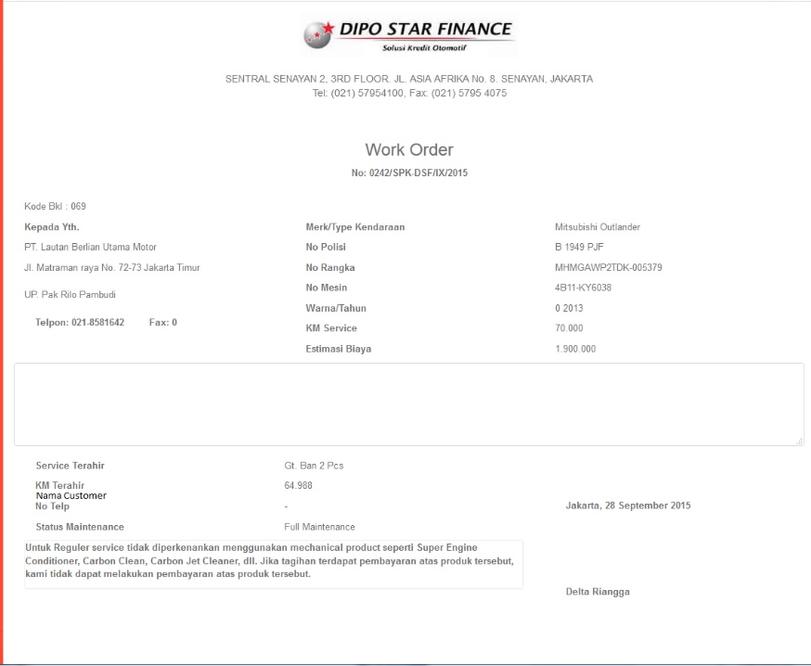

21

19

18

17

16

15

14

8

12

11

10

9

7

6

5

4

2

1

20

13

3

* 1. Entity Relationship Diagram

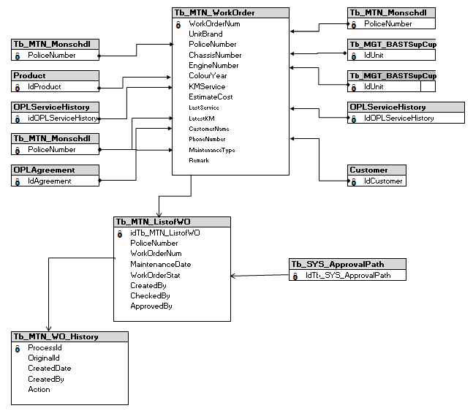

**APPENDIX**

Configuration Access for Manage Work Order:

|  |  |  |  |  |  |  |  |
| --- | --- | --- | --- | --- | --- | --- | --- |
| **User** | **Branch** | **Functions** | | | | | |
| **Display List** | **Create** | **Edit** | **View** | **Print Form** | **Print Report** |
| PIC Maintenance HO/Branch | One | V | V | V | V | V | V |
| Area |  |  |  |  |  |  |
| All |  |  |  |  |  |  |
| Marketing Officer | One | V |  |  | V | V | V |
| Area |  |  |  |  |  |  |
| All |  |  |  |  |  |  |
| Head of Branch | One | V |  |  | V | V | V |
| Area |  |  |  |  |  |  |
| All |  |  |  |  |  |  |
| Head of Department | One |  |  |  |  |  |  |
| Area |  |  |  |  |  |  |
| All | V |  |  | V | V | V |
| Regional Manager | One |  |  |  |  |  |  |
| Area | V |  |  | V | V | V |
| All |  |  |  |  |  |  |
| Advisor | One |  |  |  |  |  |  |
| Area |  |  |  |  |  |  |
| All | V |  |  | V | V | V |
| Director | One |  |  |  |  |  |  |
| Area |  |  |  |  |  |  |
| All | V |  |  | V | V | V |
| President Director | One |  |  |  |  |  |  |
| Area |  |  |  |  |  |  |
| All | V |  |  | V | V | V |
| Shareholder's Meeting | One |  |  |  |  |  |  |
| Area |  |  |  |  |  |  |
| All | V |  |  | V | V | V |
|  |  |  |  |  |  |  |  |
| **Legend:** |  |  |  |  |  |  |  |
| V = Have the access |  |  |  |  |  |  |  |